Pre-Order Lunch Form
Description | Price per Item | QTY
Ham & Cheese Sandwich lunch box | $9.34
- Include: bottle water,
Gatorade or juice, Chips, Pickle and Cookie
Turkey & Swiss Cheese Sandwich lunch box | $9.34
- Includes: bottle water,
Gatorade or juice, Chips, Pickle and Cookie
Chicken Salad Sandwich lunch box | $9.34
- Include: bottle water,
Gatorade or juice, Chips, Pickle and Cookie

Tournament Day: Saturday, February 29, 2020 Team # _______
Total number of lunches = ________
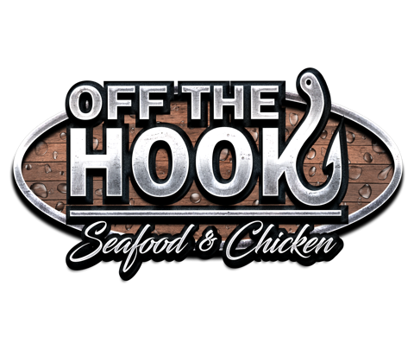
Please submit all orders by Tuesday, February 25, 2020
Sweet Cold Treats Dba Off the Hook

PO Box 5059, Greensboro, NC 27405

Please text orders to (336) 209-8724 or Email orders to sweetcoldtreats@aol.com
FORMS OF PAYMENT: ALL CREDIT CARDS, CHECK AND CASH
**May pay on site day of event**
Thank you for your business.

